1. **Retrieve all products in the "Electronics" category**

sc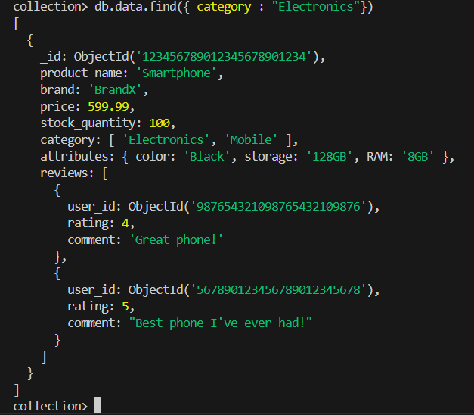

**2 Find all products with a price less than $500.**

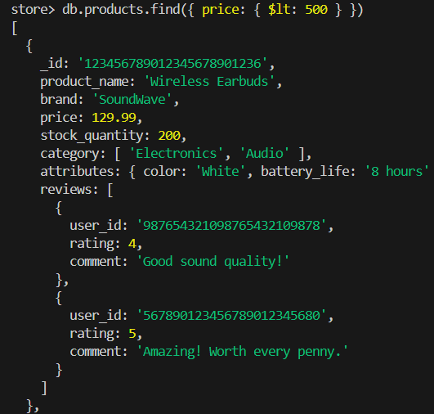

**3. Retrieve all products with a rating greater than 4**

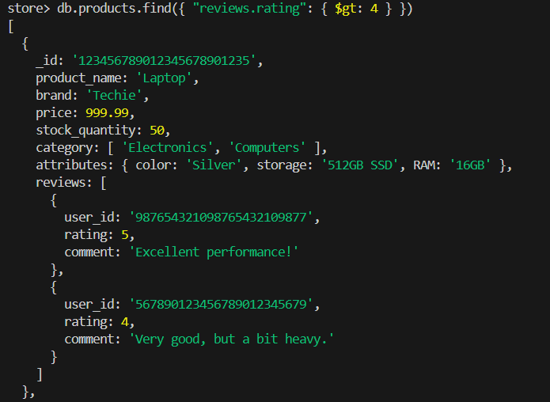

**4. Find all products with a specific colour (e.g., Black)**

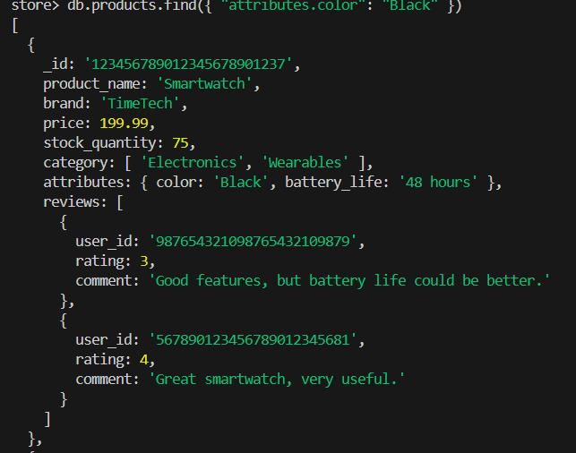

**5. Retrieve all products sorted by price in descending order:**

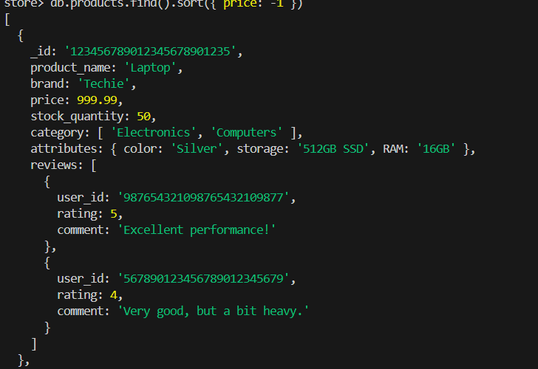

**6 Calculate the average rating of all products**

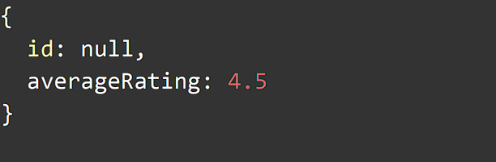

**7. Find all products where the stock quantity is less than 10**

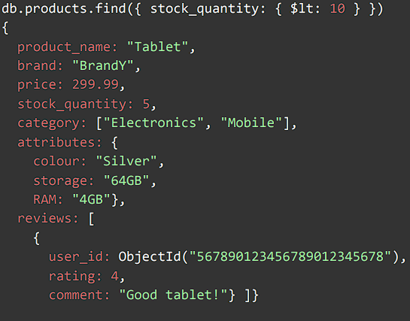

**8.Retrieve all products with a specific brand (e.g., BrandX).**

**k**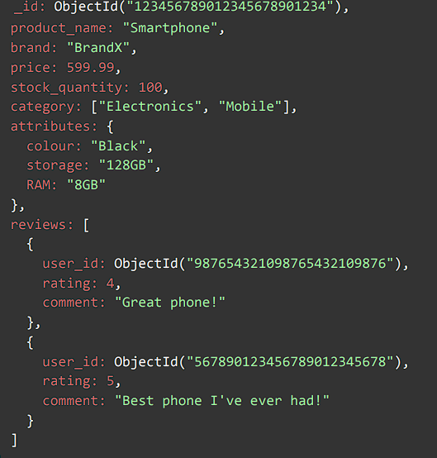

**9. Find all products where the storage is 128GB and RAM is 8GB.**

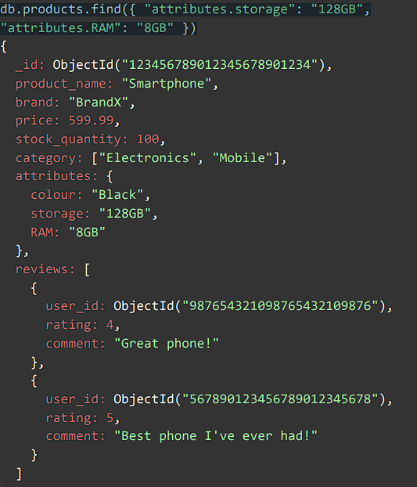

**13. Find all products with a specific category (e.g., "Mobile") and a stock quantity greater than 50.**

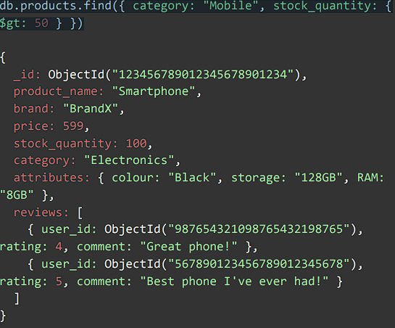

**14. Find the highest rated product**

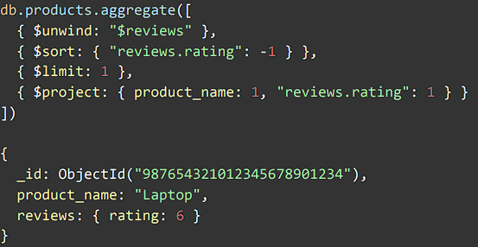

**15. Retrieve all products sorted by brand in ascending**

**order and then by price in descending order.**

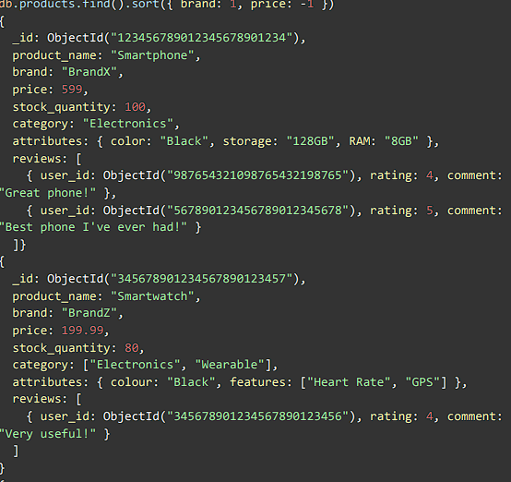

**16. Find all products with a specific comment in their reviews (e.g., "Great phone!")**

